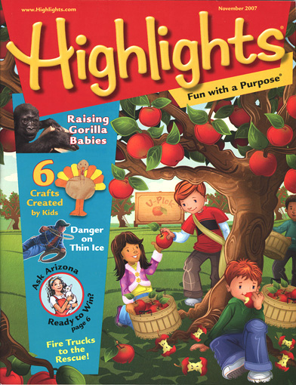

Highlights Magazine

Highlights is a exceptional magazine. Maybe you have fond memories of doing the hidden pictures, reading the jokes and poems, and learning something from the nonfiction story each month. It is an accomplished magazine that we all remember. How exciting is it for the children to get a magazine in the mail each month! As a school, we are able to offer it to you at a discounted rate. A few times a year, I will send home a slip with the children. As a class we are able to receive free merchandise and even a free class subscription if the children return the slip. I understand that many of you may already subscribe however, if you mark yes or no and return it to school, it helps our class. If you choose to subscribe, please be aware that no money needs to be send in now. Highlights will bill you privately in accordance with the discounted offer presented to you.

Thank you in advance for returning the slips!

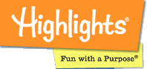
Click here to learn more about highlights

